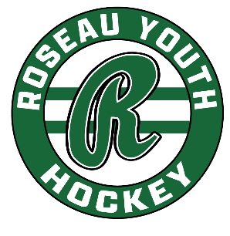
RYH Board Meeting | May 20, 2025
Gene’s, 6:30 pm
In Attendance: Phil, Mike, Jenni, Paul L, Paul B, Matt, Luke, Zach, Trevor, Keith

Agenda:
- Call to Order: 6:34 meeting called to order.
- Approve Agenda: Luke motions to approve agenda, Paul L seconds, agenda approved.
- Secretary’s Minutes: Mike motions to approve, Zach seconds, minutes approved.
- Treasurer’s Report: Mike motions to approve, Paul B seconds, report approved.
- Standing Committee Updates:
  - North Rink: Reminder to remove last remaining gear before we lock doors for the summer (communicated via email). The cold side NR locker rooms still need to be painted green/white. Volunteers might be needed to complete that work.
  - Player Development/Coaching: Luke and Mike are prepping for summer camps. Currently at around 40 registrations for Shooting Camp – would like to see about 75 registrations.
  - Fundraising: Fair Stand management is needed. We do have a few interested parties. Paul L. has license at his office. School did discuss board advertising for the school (boards, maybe fences at fields). Paul has had conversations with school board members on school/RYH joint involvement, which RYH does not see as a viable option at this point.
- Review City agreement: Mike will email some numbers to the group, with a few options for a proposal. (Starting Fall 2026) The City would like to see RYH contribute more than the current agreement.
- Approve Administrator payment: Matt motions to approve, Zach seconds, payment approved. Keith continues…
- Adjourn/Next Meeting: Adjourned at 7:38 pm

