
Team Manager Expectations/Preferred Practices
November 12, 2025

Thank you for being a team manager! Your primary role is to serve as a liaison between the Coach and the team’s families. Your job is to help organize and manage all off-ice activities and communicate team-related messages. Keep in mind that your responsibilities will change depending on the level you’re managing and the relationship with your Coach. Communication is key!
Team Communication:
- Primary role is to share communication with the team’s families
- Crossbar app/team webpages should be the primary means of communication with your team
- Preferred practice: Keep schedule updated! Include practice times, games, tournaments, 50/50, special meetings, making hotel reservations, any/all team events in the app. This means it’s your responsibility to check facility schedules and update the app accordingly.
  - Family calendars don’t work unless we input information – so keep the app updated!
- Team Webpages: When you post to the Team Feed, that goes to parents’ email.
- Preferred practice: Share the link to your team webpage in the app’s chat.
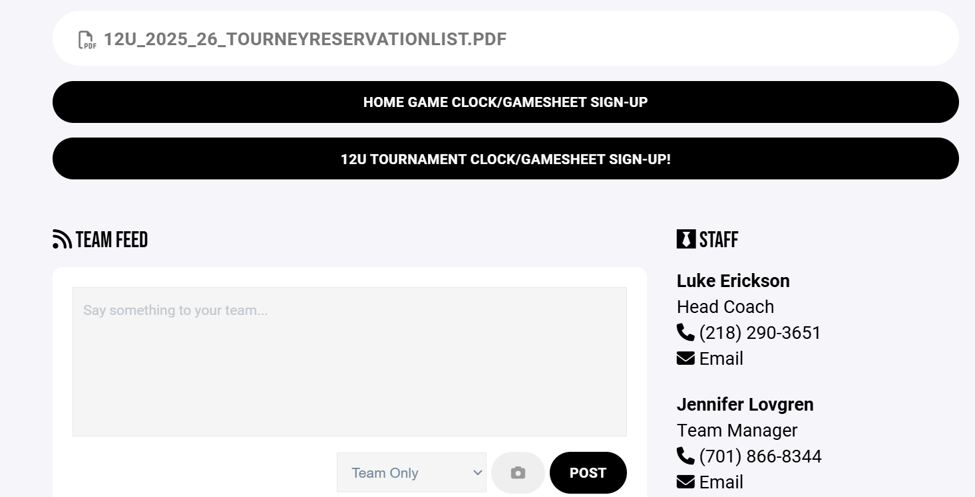

Creating Volunteer Sign-Ups:
- https://scribehow.com/viewer/How_To_Create_A_Volunteer_Session_For_Hockey__WMg_3q74Q6OmyrlbKjVH5Q
- It is your responsibility to create volunteer sign-ups for weekly locker room cleaning, locker room monitoring, home game clock/book coverage, and tournament shift coverage for your team.
- After creating these sign-ups, it’s your responsibility to share them with your team (post them to the team’s webpage and share via the app chat). Keep your eye on these sign-ups and communicate needs to your team.
Hotel Reservations for Travel Teams:
- It is your responsibility to make and communicate hotel reservation information for your team for travel weekends. Book early! Most hotels require that reservations be made (in a block) a month prior to your stay.
- Recommend sharing a list of the season’s hotel reservations to your team’s webpage and share that link to the Crossbar app chat.
Team Checkbook:
- Conversation with you (Manager) and the Coach
- Helpful to have a team debit card for purchasing team meals
- Citizens contact?
Tournament Coordination:
- Managers usually take on the role of Tournament Director/Host, but it is not required. A parent is also able to step forward and take on that role and/or help with specific tasks, such as clothing orders, team meal, etc.
- Preparation for the tournament usually starts about a month in advance.
  - Identify teams attending tournament, find team-specific contacts (email and phone for Coach/Managers)
  - Get tournament schedule from Keith or Bill
  - Prepare a clothing order (not required, but can be a good team fundraiser)
    - https://forms.gle/r9k2aa1Zt44TK5i7A (Sample ordering form)
  - Email teams (see sample welcome letter/email), share schedule, tournament rules, request rosters and/or share Gamesheet links, clothing order forms/links.
- Gamesheet set-up
- Volunteer shift sign-up (total number of shifts divided by number of players = number of shifts each family needs to cover)
- Organize rink cleaning for before and after tournament
  - Each Roseau team should vacate and clean their locker rooms each Thursday before tournament weekends (as team managers – you should remind your team to do so)
  - Host team will sweep/mop the lobby/public restrooms, warming areas, empty garbages, make sure bathrooms are stocked with paper towels/toilet paper
  - After tournament, host team also cleans out locker rooms, in addition to public areas. Again, sweep/mop, sanitize, empty garbages.
  - Preferred practice: Only need 5-6 volunteers to clean – try splitting team families up for pre-post cleaning, be specific about cleaning assignments
- During tournament – manage Gamesheet (Sunday updates must be done on a desktop/laptop, not phone)
- Provide paper/pens in box
- Make sure microphones are working properly
- Game pucks on ice, warm-up pucks available in all rinks
- Crowd control if needed
- Remind families that when working clock/book, they are off-ice officials, should remain neutral
- Collect any money from visiting teams for clothing orders, etc.

Special Assignments:
- Squirt/10U Team Managers: Work together to design/order pins for Fargo International Tournaments. Pins should be ordered no later than November/December each year!
  - Steelberry
- Bantam/12U Team Managers organize and assign the 50/50 schedule for the season and keep tabs on stock of tickets (ordered through Multi Paper Office Products/Donn Haugen)
  - 12U Manager – Sports Center/girls HS schedule, tickets in Coaches’ room
  - Bantam Manager – Memorial/boys HS schedule, tickets in Media room off Memorial lobby

