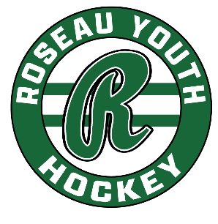
RYH Board Meeting | June 16, 2025
Gene’s, 6:30 pm

In Attendance: Paul B, Luke, Trevor, Matt, Jenni, Keith

Agenda: *This was a “work session,” not an official meeting, so no minutes/reports were approved from May nor were any motions made, etc.
- Call to Order: N/A
- Approve Agenda: N/A
- Secretary’s Minutes: N/A
- Treasurer’s Report: N/A
- Standing Committee Updates
  - North Rink – Facility security concerns (front door needs to be looked at again, concern about barring that bathroom door to the dryland room).
  - Player Development/Coaching
  - Fundraising – Fair Stand (Maranda and Steph Johnson) Paul met with them today. Ryan Muirhead will provide burger meat.
- Review City agreement – Brady would like an offer from RYH by the July city meeting. Somewhere around the $46,000 mark – 40/42 weeks of ice. Can discuss via email since we don’t always meet in July.
- Golf Tournament – Luke will need some extra help, might be good for those who cannot work Fair Stand shifts. This is an RHA fundraiser, although the Alumni association has also participated. Sometimes attendees are confused as to which organization is the beneficiary.
- Open season registration…Keith would like to open early – July. Those in attendance didn’t see an issue. Keith will work on getting that rolling soon…look for an association email.
- Adjourn/Next Meeting --

