Caterpillar Foundation Matching Gifts Program Process – Our Legal Name

- Visit www.caterpillar.com/matching-gifts and click on “Visit Website” under “Caterpillar Participants: Search/Request a Match”
fg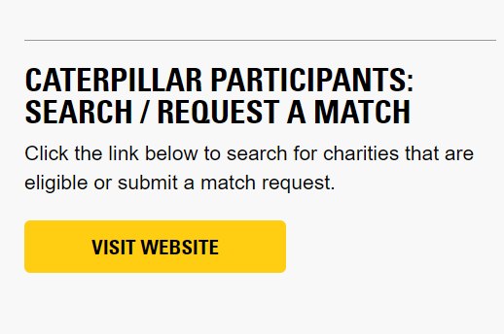

- Register as a first-time user OR login as an existing user. Use your 7-digit HR ID (formerly known as PeopleSoft/HR ID - found in CLUES). Make sure that you include the leading “0” at the beginning of your ID (0_ _ _ _ _ _) so that it is 7 digits total. If you do not know your ID, email Matching_Gifts@cat.com.
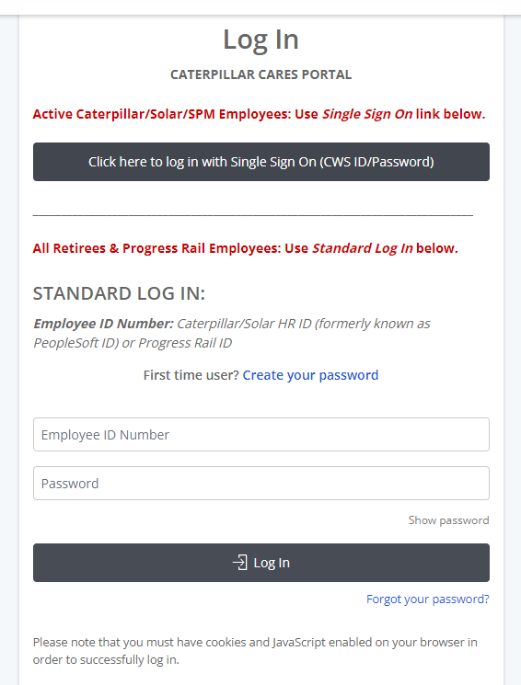

- Click “I ACCEPT” to the matching gifts terms and conditions.
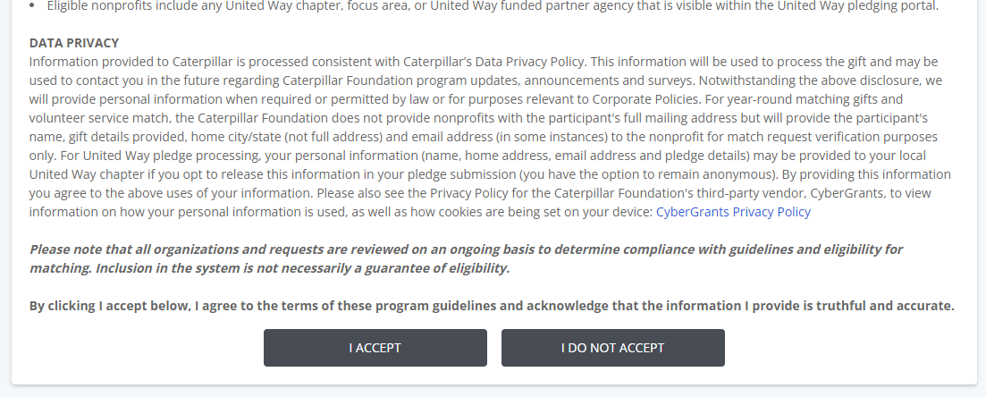

- From the home page, click “1:1 Matching Gifts”.


- In the Matching Gifts Nonprofit Search, type in “Morton Grid Iron Club” and click “Search”.
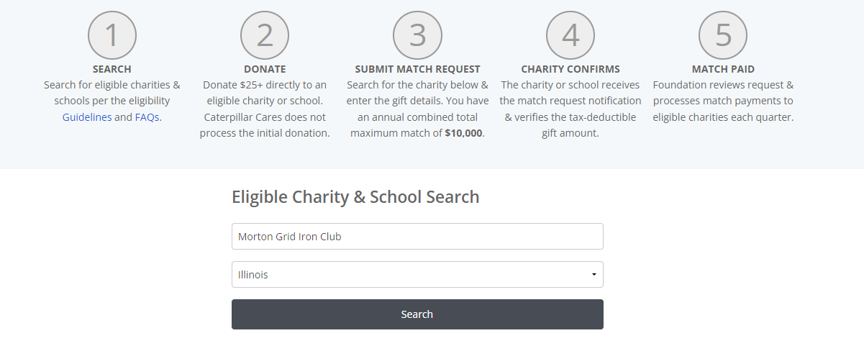

- Click on “Select” next to “Morton Grid Iron Club”.

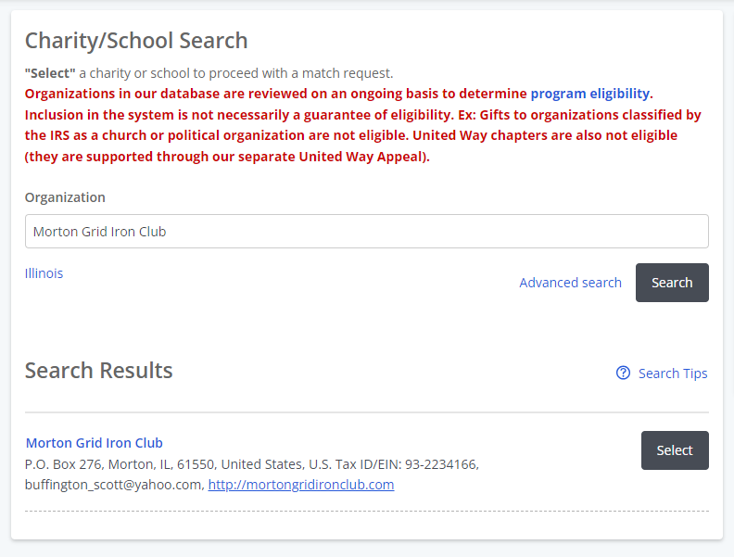

- Enter gift details. If you would like a specific Sports Team to get credit for this matching gift, type the Team’s name, in the “Designation” field. Click “Save and Proceed”.
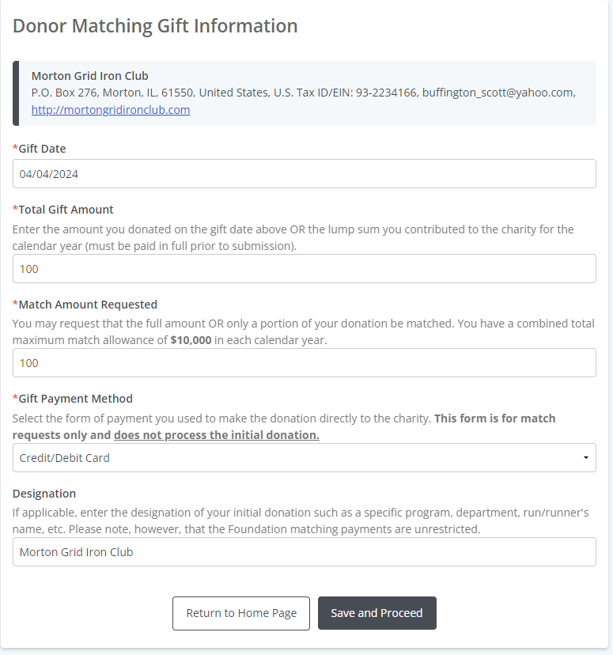

- Review, update (if necessary), and then click “Submit”.
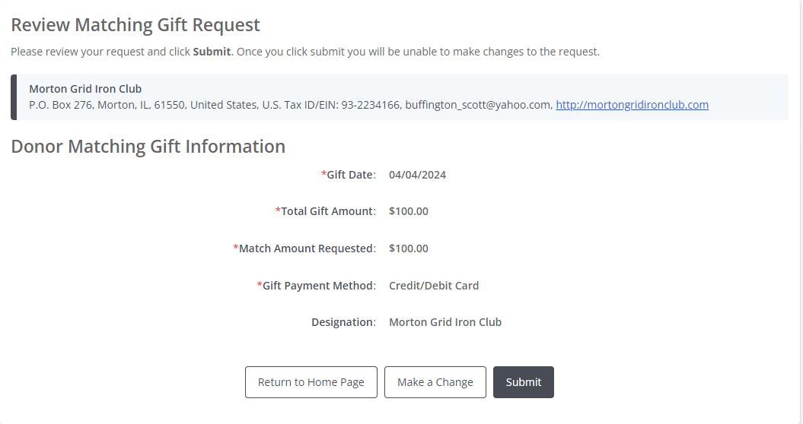

- Click “Email Match Request to Charity” or “Print and Mail Request to Charity”.
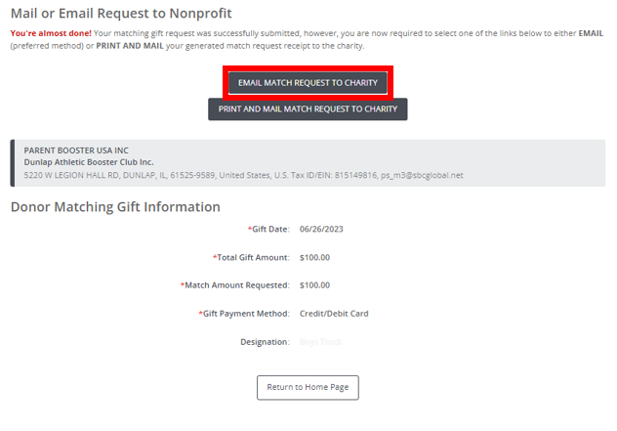

- To email, enter Gregory.jaeger@yahoo.com into the recipient field. Scroll down and click “Preview”. (You do not need to upload any attachments or include additional messages.)
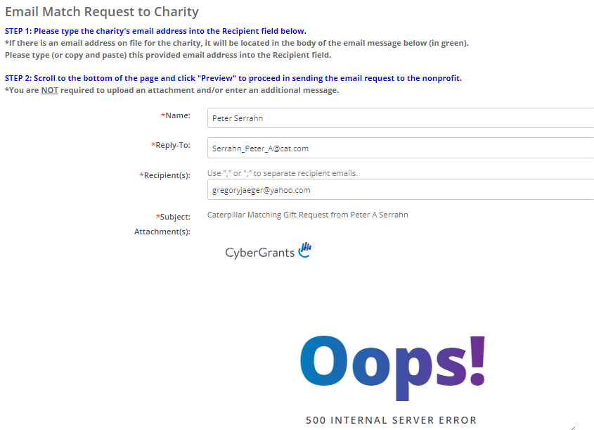

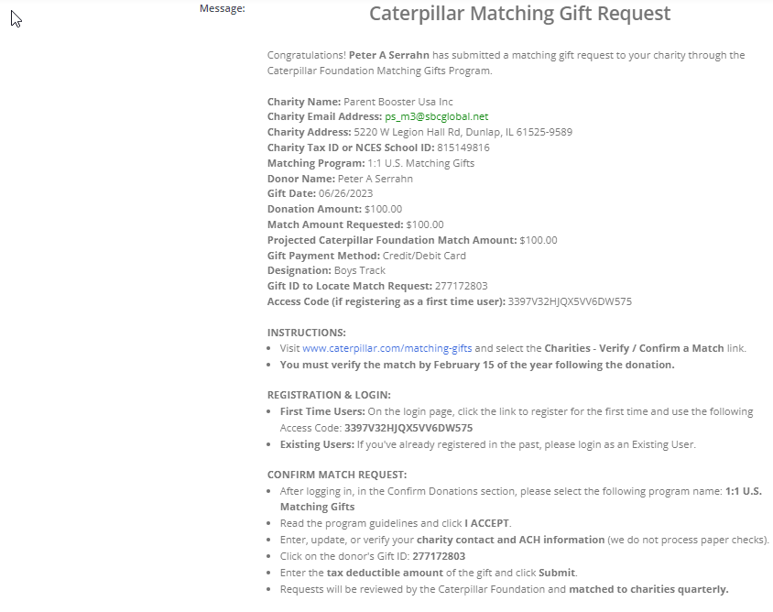
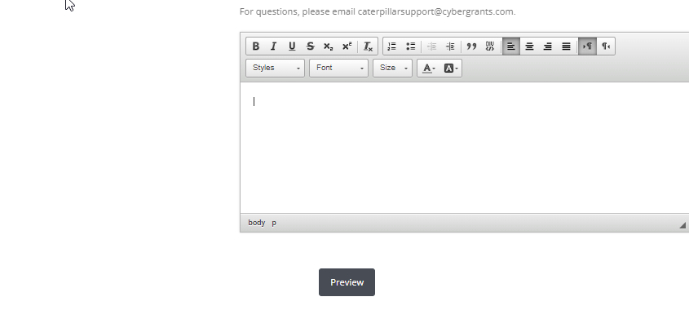

- Scroll down and click “Send”. The process is then complete!
