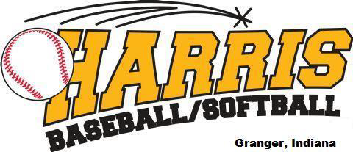

2026 Minors Rules

50/70 Distance
6 run max per inning, 10 run Mercy Rule after 4 innings
Regulation game is 6 innings, 90 min. time limit, or 4 innings if the game is called by the umpire.
An inning can be finished after the time limit is reached but no new innings. The sling-style pitching machine should be placed directly over the pitching rubber on fields 3.

Gameplay Rules

This division will use a hybrid pitching model that combines a sling-style pitching machine with player pitching to create a balanced and positive learning environment.
- The sling-style pitching machine will be used in the first – third inning
- In the fourth inning the game will move to player pitch and will stay player pitch through the completion of the game.

Batting Rules

Sling-style Pitching Machine Innings:
- A batter will receive 5 pitches or 3 swings, whichever comes first. If the 5th pitch is a foul ball, the at-bat continues. If the batter does not swing at the 5th pitch the batter will be called out. There are no strikes called.
Player Pitch Innings:
- During the player pitch innings, traditional baseball rules will be enforced.
  - Strikes will be called by the umpire.
  - 4 balls will result in a walk (Coaches will no longer throw to a batter).
  - A batter that is hit-by-pitch will be awarded first base.

Pitching Rules

Everyone will follow the “Pitch Smart Program.” A copy of the program will be on our website.

Base Running Rules

- Steals are permitted at 2nd and 3rd base, but only after the ball crosses the plate.
- Lead offs are not permitted.
- Balks will be used as a teaching lesson for the pitchers but will not be enforced.
- No delayed steals.
- Once the catcher has secured the ball, and the runner has stopped forward progress, the runner must immediately return to their base. The ball remains live though. If the catcher makes an errant throw to the pitcher, the runner can then attempt to advance.
- Players may advance on over-throws at 1st and 2nd base.
  - From 3rd base, the runner needs to be batted in.
- Headfirst slides are not permitted.
- A player must slide if there is a play at the base. If they do not slide, they will be automatically out.
- No Infield fly rule.

Playing Time

- All players must play minimum of 2 innings in the field. The whole roster bats all game.
- No limits or restrictions on the number of innings at 1 position.
- Teams may play with 8 players. If only fielding 8 defensive players, a 9th defensive player can come from the opposing team if requested and should be the player that made the last out the inning prior.

Batting/Bats

- USA Bats only.
- No bunts.

Tie Breakers for End of Season Tournament

- Winning Percentage – Descending
- Number of Wins – Descending
- Number of Losses – Ascending
- Head to Head Winning Percentage
- Avg. Runs Allowed – Ascending
- Avg. Run Differentials with a maximum of (8) – Descending
- Coin Flip

