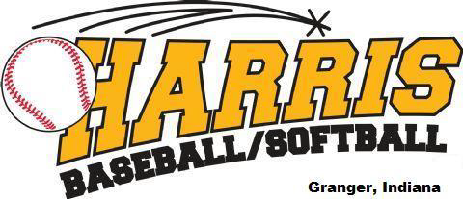

2025 Machine Pitch Rules

No inning will start after 1 hour from the start of the game
All games are 75 minutes or six (6) innings, no new innings finish the inning even if it exceeds the time limit
Machine Pitch is set at 30-32 MPH from 35 feet. The machine should be placed directly over the pitching rubbers on fields 5 and 6

Rules:

- Both team managers must agree to the machine speed and pitch height at the beginning of the game. Once the inning starts, the machine should not be adjusted until a full inning is complete. Again, the managers of both teams must agree and continue play.
- Batting orders must be exchanged between teams before the game begins.
- Teams must bat every player on their roster.
- A batter will receive 5 pitches or 3 swings, whichever comes first. If the 5th pitch is a foul ball, the at-bat continues. If the batter does not swing at the 5th pitch the batter will be called out. There are no called strikes.
- Every player must play the infield for 2 innings. The catcher counts as an infield position. A player is not permitted to play the same infield position for more than two consecutive innings. Once they have played the same position for two innings, they may not return to the position later in the game.
- No traditional bunting allowed. If a batter SWINGS the bat and the ball is hit softly in front of home plate, it is a live ball. Home plate is in fair territory.
- If a batted ball or ball in play hits the pitching machine, it is considered a dead ball. The batter is awarded first base. Base runners may advance to the next base only if they are forced to.
- No stealing. No leadoffs. No pinch runners. No infield fly rule. No obstruction or interference rule.
- The pitcher must wear a batting helmet and heart guard while playing the pitcher position.
- Outfielders may not run to a base to make a force out. Encourage them to throw the ball to the base and teach an infielder to cover the bag.
- Once the ball is controlled in the infield dirt or pitching circle, time is called and play stops. Controlled means the player has the ball in their glove or bare hand.
- Runners who are on or across the white hash marks in the baseline, may advance to the next base when time is called. Those who have not, must return to the previous base.
- Runners may not advance on overthrows at any base this season. We are trying to teach players to make plays at the bases.
- You may add extra outfielders to the outfield to avoid kids sitting on the bench. There are catchers this year.
- Coaches may be on the field during the game. Defensive coaches must be in the outfield or provide instruction from the dugout. Offensive coaches must be the in 1st or 3rd base coach box. A third coach will feed the pitching machine.
- The half inning ends with three (3) outs or when a team scores six (6) runs.
- The game is over when it is mathematically out of reach. If the game ends because of the run rule, you may continue to play for fun and opportunity.
- The field umpire will make calls regarding the batter pitch count, outs, and runner advancement this year.
- Encourage and promote sportsmanship at all times.

Tie Breakers for End of Season Tournament

- Winning Percentage – Descending
- Number of Wins – Descending
- Number of Losses – Ascending
- Head to Head Winning Percentage
- Avg. Runs Allowed – Ascending
- Avg. Run Differentials with a maximum of (8) – Descending
- Coin Flip

