How to Trade Ice from one
Rockets’ Team schedule to another Team Schedule
There is no automated way for Managers or Coaches
to move sheets of ice from one Team Page to another
Team Page on the Rockets’ Crossbar web site.
It must be done manually.

Step #1: Confirm with the other Coach/Manager what ice you
want to swap/trade. (write it down)

Step#2: If you’re receiving the sheet of ice you go to your Team
Page & click on the “+Event” tab in the upper right corner 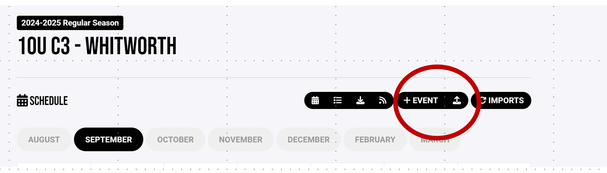

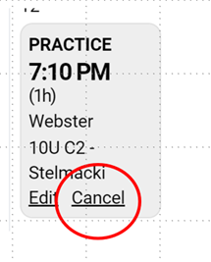
If you are giving away the ice/trading ice, you first confirm the Trade with the other coach/manager, and then you simply “Cancel” the sheet of ice on your schedule and the system will delete it from your calendar only.
Step #3: Once you click the +Event button this window will open and give you options to schedule what type of event you want.
(i.e. Game, Practice, Training, Meeting or Other event)

Game Event window
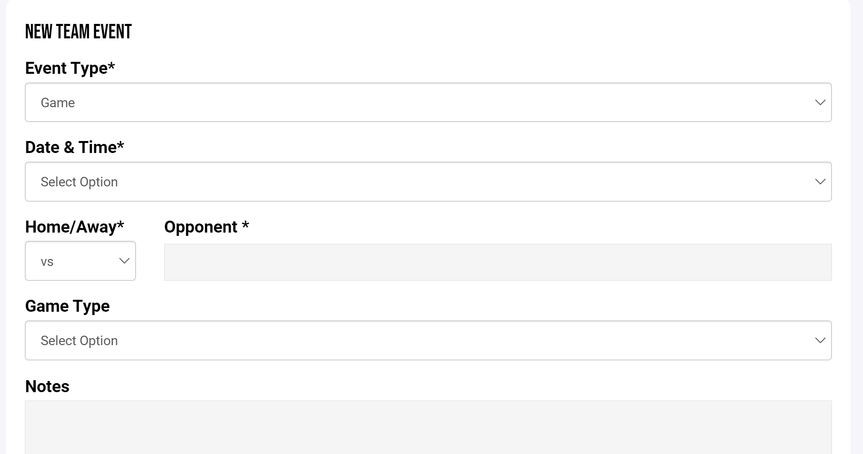
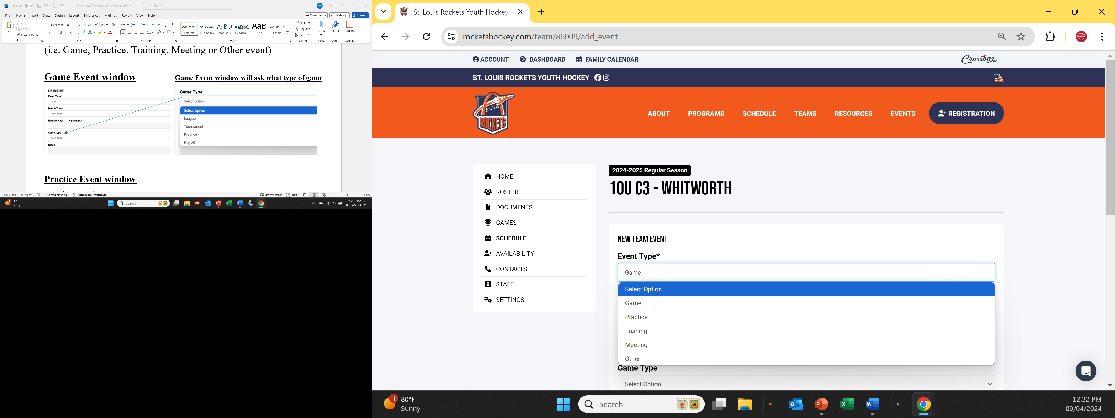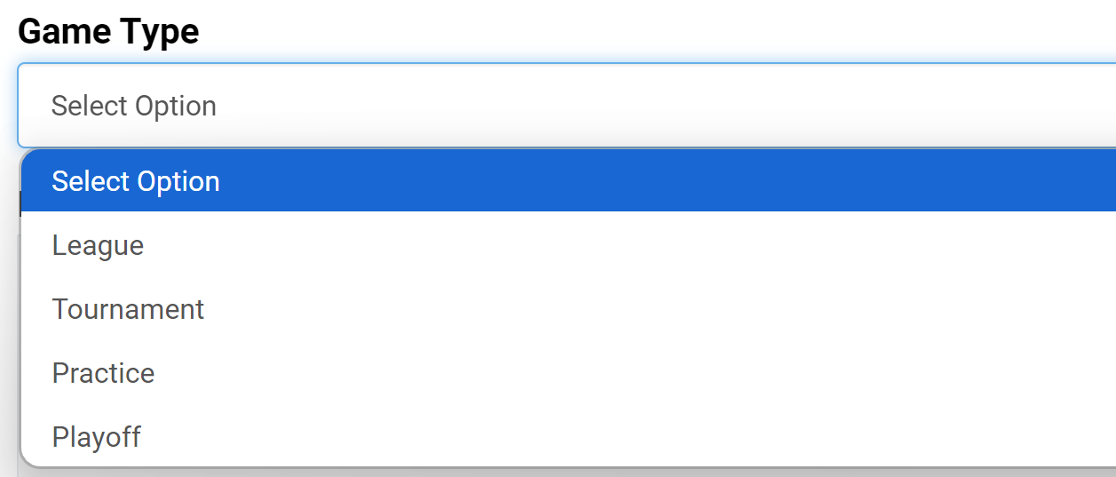
Practice Event window
Just basic information
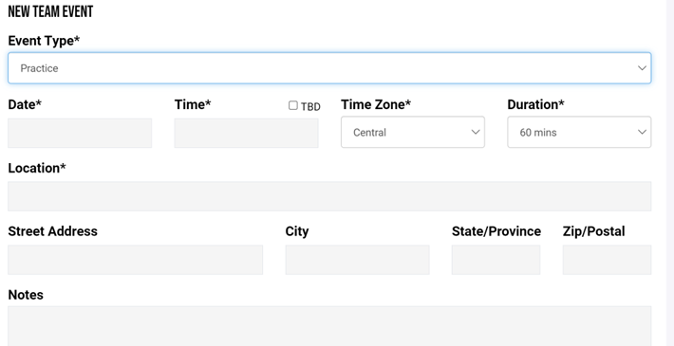
Training, Meeting or Other Event Type window
This window allows you to add a specific title to your event
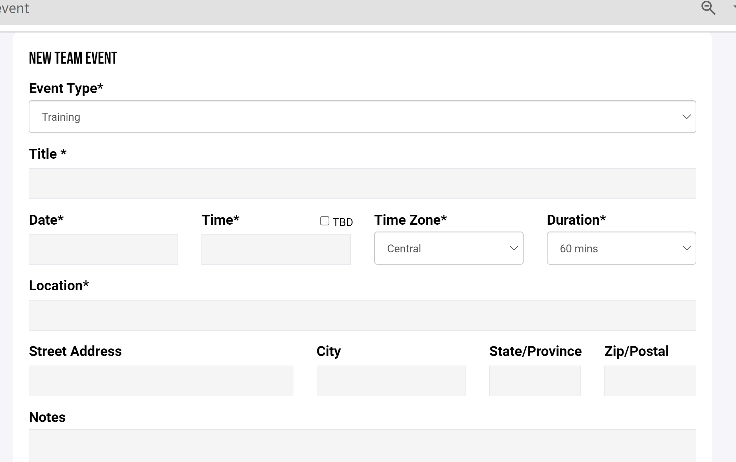

Step #4: Take the ice information you want to add, type it in with all the details and hit the “Save Event” button.

Should be on your schedule as a modifiable document.

Sharing Ice:
If you are giving away your ½ sheet of shared ice all you have to do is delete it off your schedule. It will not effect the other teams schedule. If you getting a shared sheet, add it to your schedule and put in the notes that it’s a shared sheet.

Note: Please let us know if you have found any ways to make this process easier. We are still looking on options via Crossbar and will keep all of you posted on any progress.
KDW 9/24

