Champion Center Clock Cheat Sheet
FCS Boys Hockey ’25-26: Rhiannon Thoresen, 920-202-0001

The control console for the score board/clock at the Community First Champion Center is a Daktronics All Sport® 5000 Series. This clock is the one of the friendliest you’ll find (says the Mom with 12 years of experience and volunteering). I guarantee if you review the layout of the console and apply a little logic you won’t need this Cheat Sheet!

The full 256 page instruction manual can be found: ed11976.pdf or scan the QRC directly on the console. However, if needed, below is Cheat Sheet in “hockey Mom” language.

The instructions below assume that the console is turned on and ready when you arrive. If not, there are instructions below on how to turn-on and set-up!

Familiarize yourself with the Console:
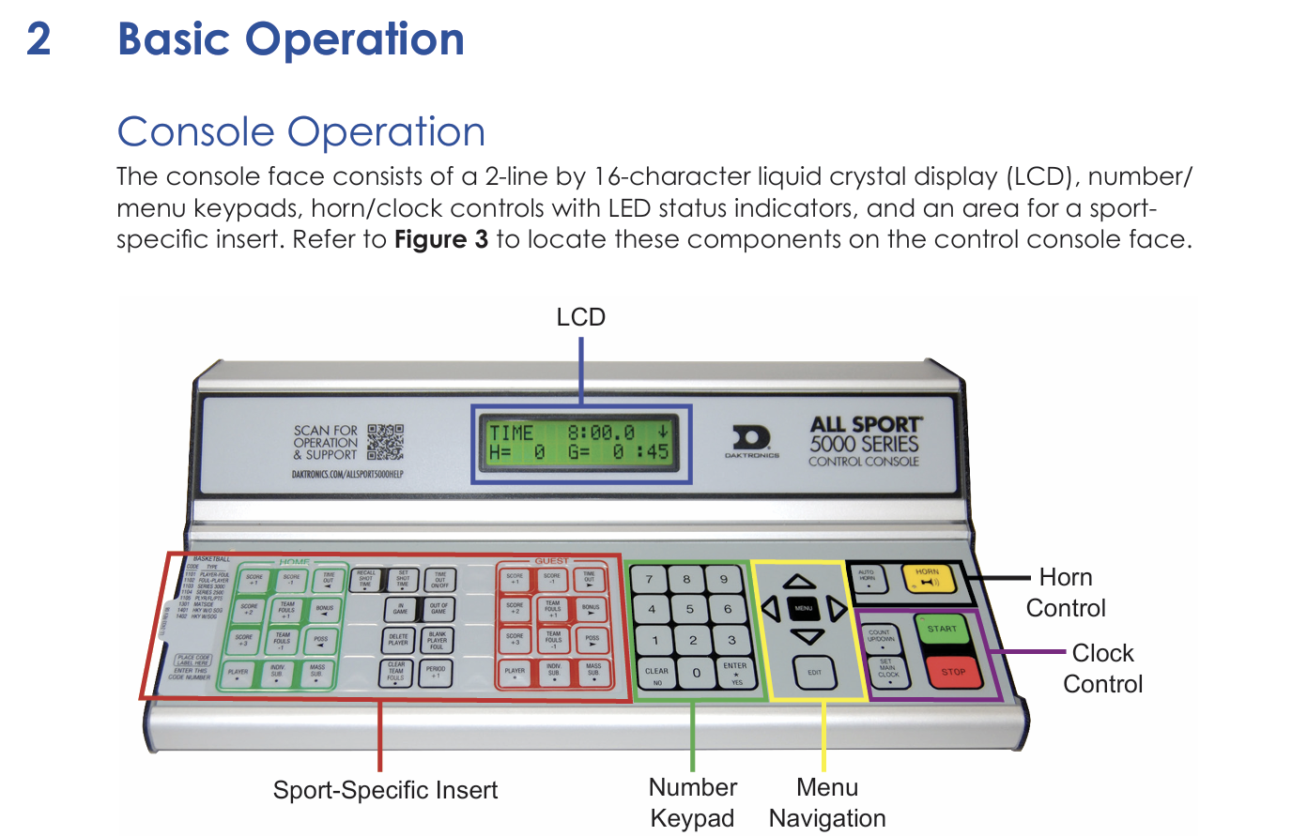
- A card specific to hockey will be inserted on the console.
- Left to Right:
  - The green bank of buttons is for the HOME team and is repeated in the red bank of buttons for the GUEST team.
  - The black buttons between Home and Away are for GAME CONTROL.
  - The NUMBER KEYPAD is similar to a computer.
  - MENU NAVIGATION – rarely used, select which penalty to clear if needed
  - HORN – just like the horn on your car – beep-beep! (mostly used to get ref attention)
  - CLOCK CONTROL is to set the main clock and control the start and stop

- The settings will show up on the LCD screen across the top but you can also look at the scoreboard, the inputs immediately show up after pressing Enter.

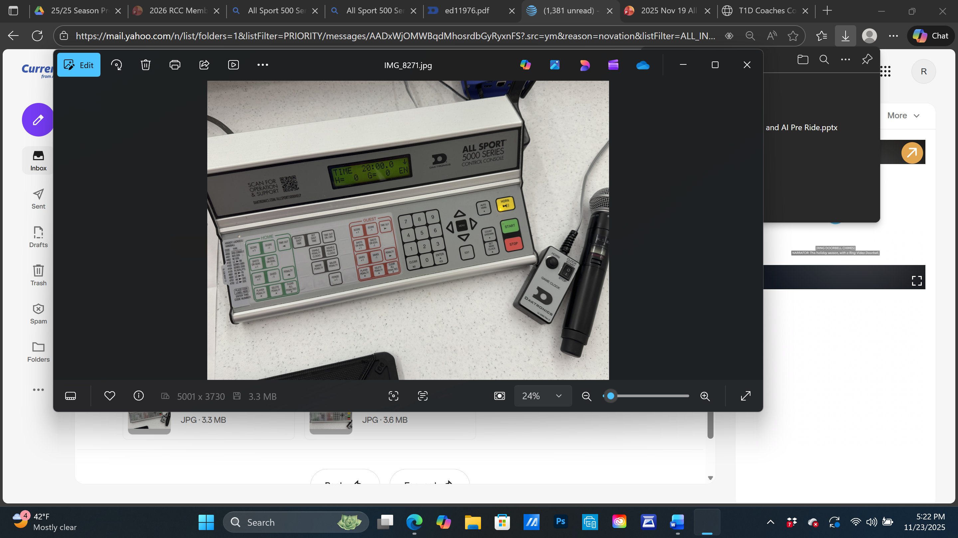
- If you don’t want to use the CLOCK CONTROL Green Start / Red Stop Button on the console, you can also use the remote control for this (a start and stop flip switch)

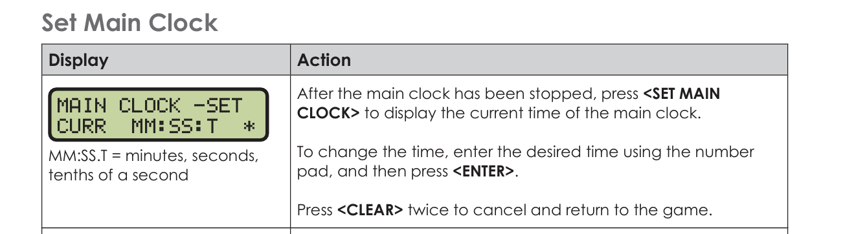

- Use Main Clock for warm-ups, time in Period, time between periods
- Do not use for Time Outs, let refs manually track a time-out
- Tip: if you’re unable to set time make sure the remote control is also flipped to the stop position. If the clock runs out at the end of the period sometimes the switch is still in the start position, the first step is, “after the main clock has been stopped”

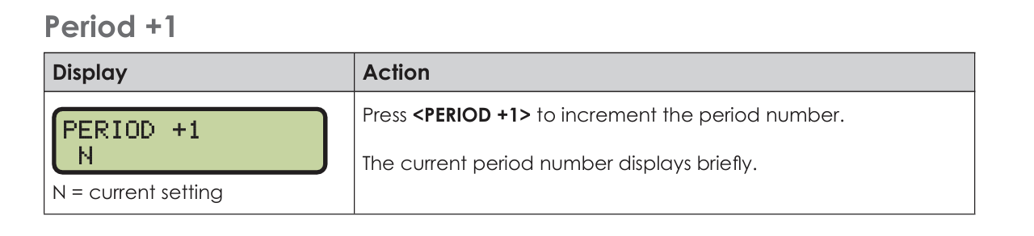
- Located in the black GAME CONTROL buttons between the home and away groupings
- Game over and want to return to 0? Press the button 6 more times

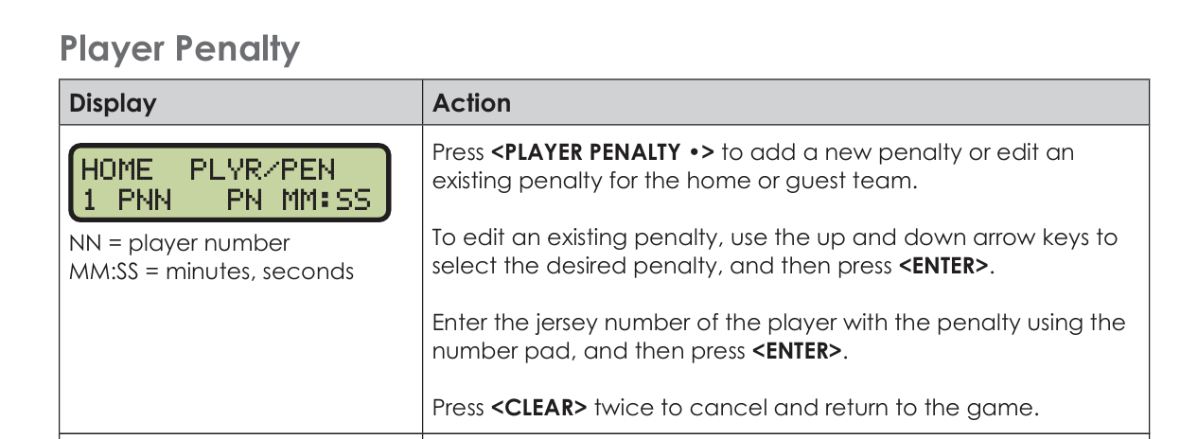

- Don’t panic if there is a penalty! You’re in control, they can’t start without you, take a breath.
- Confirm penalty times before the start of the game – a minor and a major and misconduct, you can ask the refs.
- Determine if the penalty is on the HOME or GUEST team (from the ref or watch which player enters the penalty box) and select PLAYER PENALTY from the HOME green or GUEST red grouping.
- Use the NUMBER KEYPAD to enter the player number (in two digits) <ENTER> and then the NUMBER KEYPAD to enter the penalty time <ENTER>
- Double penalty on same team, repeat
- Multiple penalties – do the HOME and then do the GUEST (or visa versa)
- This is instructions on how to use the clock but for my hockey Moms that are learning…there is something called “off-setting” penalties. This is when a player on HOME and a player on GUEST are both guilty and get a “time-out”. The ref will tell you to not put this penalty on the scoreboard, ask if you need clarity. During an off-setting penalty both players sit but the teams don’t play full strength. Work with your scoresheet keeper to determine when the players are released (AKA not before). They can leave the penalty box at the first whistle after their penalty time lapses.

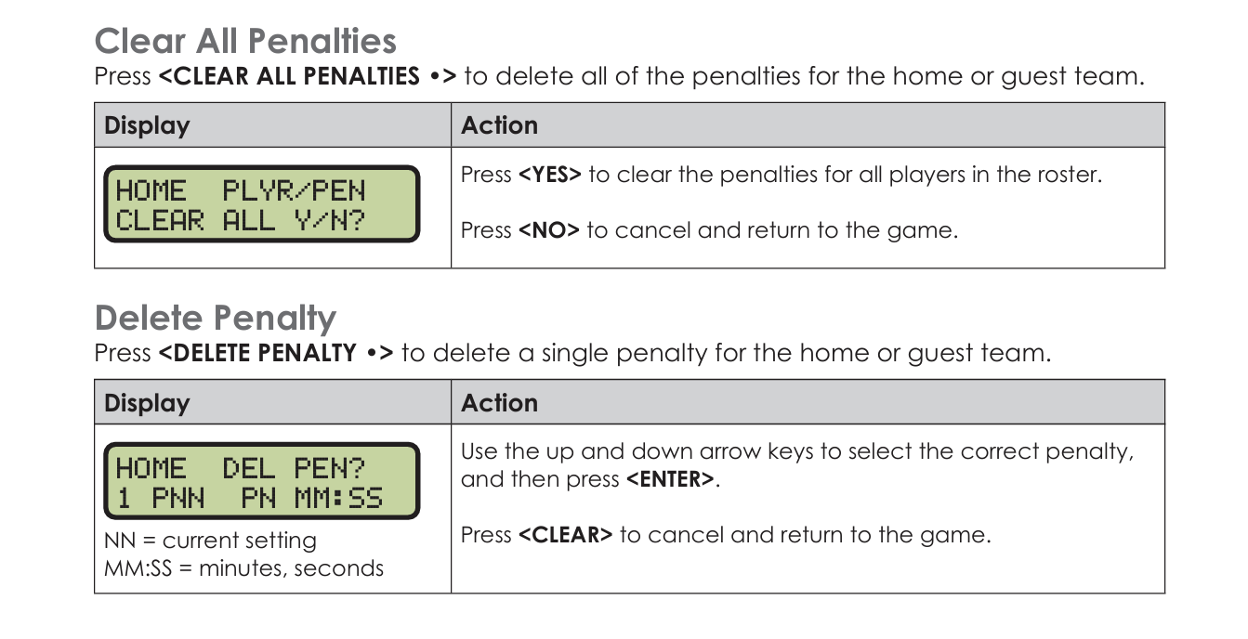

- Determine which penalty needs to be removed. HOME or GUEST team (from the ref or watch which player leaves the penalty box) and select DELETE/CLEAR PENALTY from the correct HOME green or GUEST red grouping.
- Why might a penalty be deleted?
  - You made an entry error and need to start over.
  - A goal was scored and the penalty ended before the clock expired.

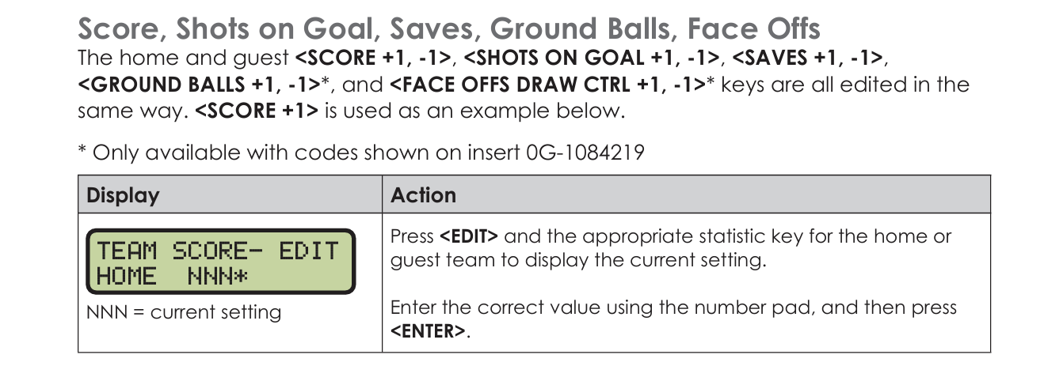
- Determine which team scored HOME or GUEST and select the corresponding Score +1
- Determine which team shot the puck, HOME or GUEST. Select the corresponding Shots on Goal (SOG) +1.
  - Have your penalty box workers help you determine and count SOG (they can see better).
- A shot on goal (SOG) is any shot that would have entered the goal if not stopped by the goalie. Shots that hit the post, miss the net, or are touched/interfered with by the goalie outside of the net do not count. A goal counts as a SOG.

POWER-On and Set-Up:

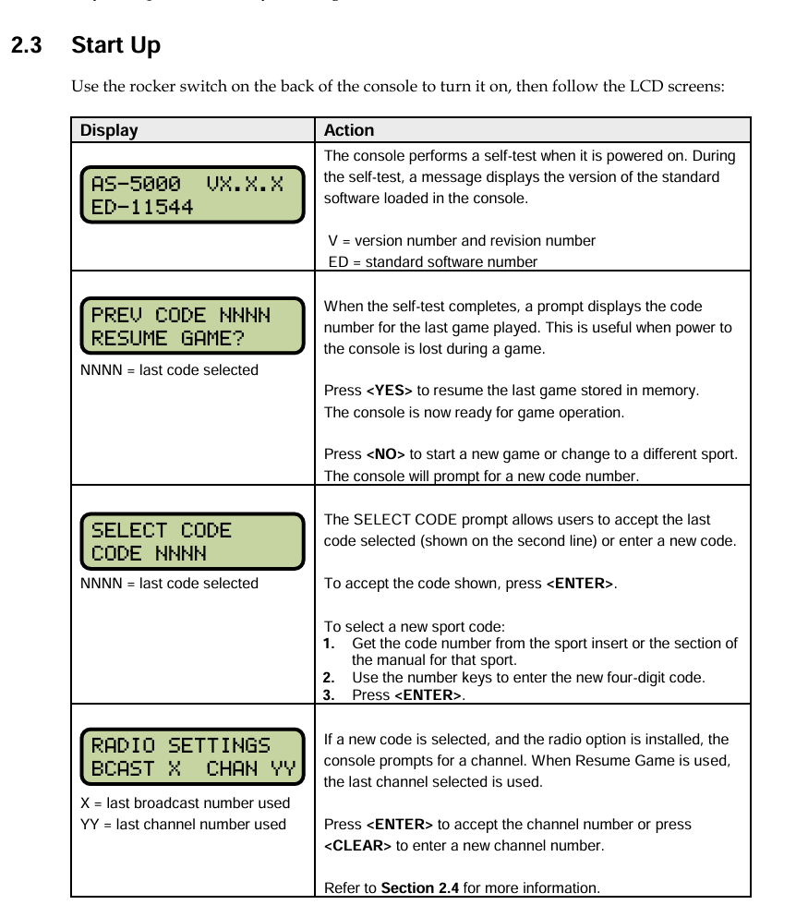

HOCKEY SPORT CODE NUMBER: 4402
- This number can be found on the console sport insert card, left hand side.

Trouble Shooting:
If the clock is not responding as expected, the previous user may have entered in the wrong code. For example, if you’re unable to tally SOG the wrong code was likely entered. Go to Menu arrow down to new code. Then type in the correct code.

QUICK REFERENCE provided in the Manual
