WIAA Unofficial Scoresheet Instructions
FCS Boys Hockey, 11/24/2025
Created by: Rhiannon Thoresen, 920-202-0001

Filling out a WIAA hockey scoresheet involves carefully recording game details, scoring, penalties, shots, and official signatures in accordance with WIAA standards to ensure accurate statistics and compliance.
- Write clearly and press hard enough to ensure all copies are legible
- Use either time remaining on the clock or elapsed time consistently throughout the game
- Confirm during the game that players listed on the roster match those receiving penalties, goals, assists. Communicate discrepancies to the referees.
- Prior to the game define whom will officially record Shots on Goal. Typically done by the penalty box as they have a clear view. However, any off-ice workers can tally and confer.
- A shot on goal (SOG) is any shot that would have entered the goal if not stopped by the goalie. Shots that hit the post, miss the net, or are touched/interfered with by the goalie outside of the net do not count. A goal counts as a SOG.
- Use a scratchpad to capture info during play (i.e. SOG tally, clock time ) and transfer neatly to official scoresheet.
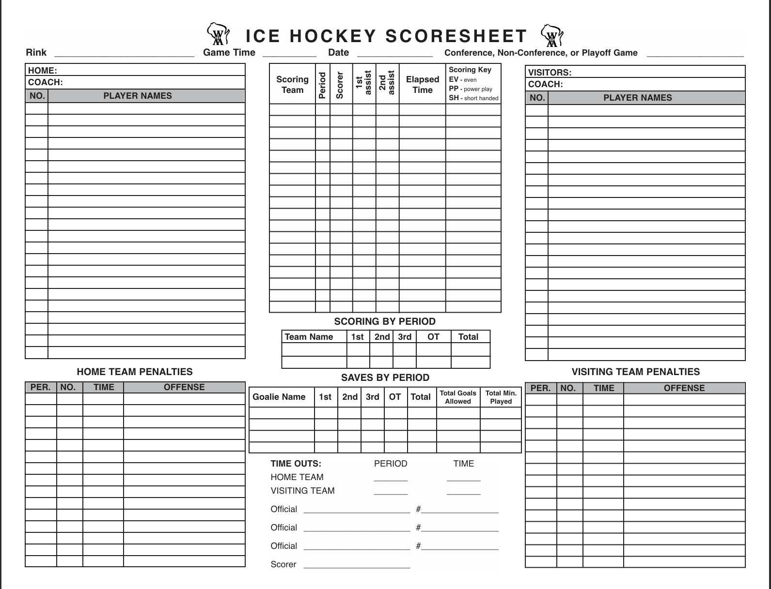
8
7
6
5
4
4
3
1
1
1
2
2
1
- Game Header – Fill in the Rink, Game Time, Date, and Circle the Game Type

- Rosters – Ensure the Home and Visitors Rosters are filled out. Team managers or Coaches can complete. Include the team’s name (JV or Varsity), coach, and players with jersey numbers. Stickers are acceptable – apply one on each of the carbon copy pages (qty 3). Allow coaches to make changes to the stickers before the game by crossing out, adding, changing jersey numbers.

- Goals – Both teams’ goals are scored in the same table. The referee will come to the scorers box to report the goal (for example, 46 from 14 and 20).
  - Note the scoring team, the period, the jersey number of the player that scored the goal (46), and the assists (14 and 20) if any.
  - Record the elapsed time when the goal was scored. This is the Game Time – Clock Time (because the clock counts down). Note: if you’d like to record the clock time just cross off the word “elapsed” and record the time on the clock so the stats coordinator is aware.
  - Goal types for the Scoring Key include:
  - EV: Even strength
  - PP: Power play
  - SH: Short-handed
  - EN: Empty net
  - EA: Extra attacker
  - PS: Penalty shot

- Penalties – Record Home and Away team penalties in their respective tables. The referee will come to the scorers box to report the penalty (for example, 71 “white” minor for tripping). Record the period, the jersey number of the player with the penalty, the game time of the penalty occurrence, and the offense (as the referee stated). If a single player incurs multiple penalties (Minor and Misconduct) they are recorded on separate lines.

- Scoring by Period – Write in the team names and record the score (number of goals) at the end of each period. At the end of the game record the total score for each team.

- Saves by Period – Write in the Goalie Names and number for each team. Record the number of saves for each period. Number of saves equals the shots of goal minus goals allowed. Record them separately for each goalie. If there is a goalie player switch during the game, write down the new goalies name. Note the time of the switch to document in the “Total Min Played” column. At the end of the game sum the totals for the Saves and note the total goals allowed for each individual goalie.
- Time Outs – Record the period and clock time if a time out is taken.
8. Officials and Scorers – At the end of the game have the officials print their name and CEP# on the scoresheet. The official scorer should also write in their name to validate the document. The officials/scorers will cross out unfilled lines to prevent alternations.

