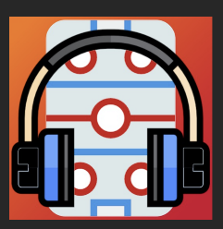
SPORTS AUDIO DJ
Instructions for Use
11/24/25

- Thoresen iPad: User Number

- Ensure device is connected to Rink audio system Bluetooth

  - Settings – Blue Tooth
  - Champion Center:
  - Tip: if having issues connecting, click on DN-500CB in the Bluetooth list and “forget this device”. Turn-off and on Bluetooth. find and connect
  - Tip: if having issues finding device, ensure no other devices in the area are using bluetooth (remove device from surrounding cell phones)

- Open Sports Audio DJ app (image of headset with ice rink in background)

- Sound Groups appear at the bottom of Screen. Tap the desired Group for the sporting event (Warm-Ups, Penalty, Puck Drop). When in doubt…use the puck-drop tab for any music.

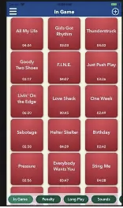

- Individual songs are the squares above each soung group. Single tap the song to start playing and tap the song to stop. The song playing is highlighted in teal. If you change music groups and can’t find the song, you can tap on the timer in the upper right corner to stop the song. Songs are programed to start and stop at specific times avoiding language or content.
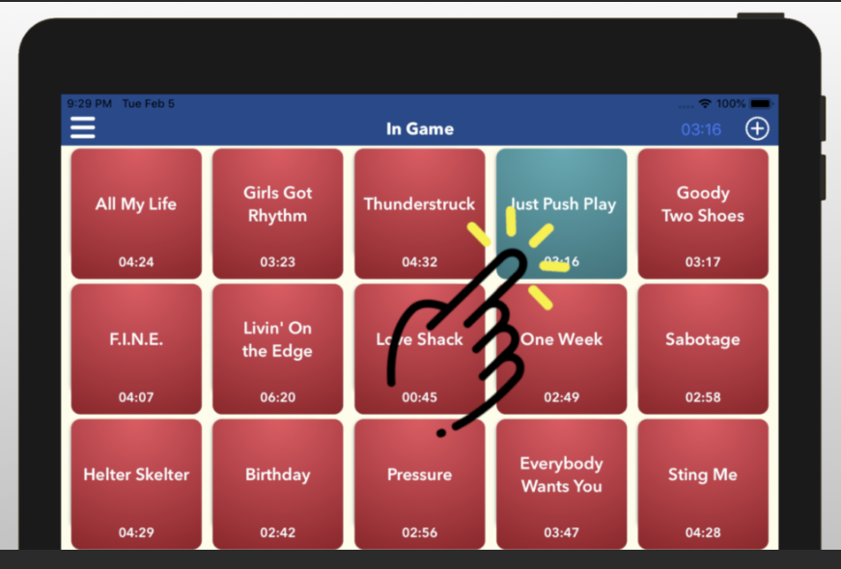

- Once played the song will change the square color from bright to dull color to prevent repeats (for example, from Red to Pink). If you want to repeat you can tap it again.

- To clear the “already played” songs tap the menu button and select “clear ‘Has Played’ flags”

- STARS SPECIFIC SONGS are positioned in the play list in the upper left hand corner and are colored in RED:

  - WARM-UPS including: Energy (Drake), Turks (Nav), Run This Town (Jay Z), Power (Kanye), Booyah (Showtek), Welcome to the Jungle, Look Alive (BlockBoy)
  - Take the Ice after Zamboni: Sirus
  - PLAYER ANNOUNCMENTS: Narco
  - GOAL: Click on Chicago Blackhawks to hear the goal horn and then tap Free-Bird

- Return iPad to Thoresen family or Michelle Robb at end of game.

Tips:
- Occassionally the app will reduce volume, you may have to manually increase on the iPad. The sounds in Champion Center main rink is quiet on the player side, it’s maxed out on the stands side.
- If the app freezes, just close it out and re-open. You will have to turn the iPad volume ALL THE WAY UP after you do this.
- Be patient with button pushes. Don’t over tap – look at the timer in the upper right corner for confirmation the song is playing. When it’s super cold the iPad can be a little slow, sometimes it helps to plug it in.
- Color Coding:
  - Red colored songs are requested by the Stars Players and Coach, play these first
  - Blue/Purple are general
  - Gray (especially in the Penalties and Goals) are for the opponent
  - Yellow (in the Penalties) are for when there is a double penalty – One for Stars and One for Opponent
- The app is run off of our personal iTunes account. When songs on iTunes change, it may give you a warning in the app. Just delete the song by double clicking and then long hold - trash can in right corner.
- If you want to add songs, go for it! Upper right corner is a “+”. Select iTunes. You may have to go into the iTunes app first, find the song and add it to the library. Then go back into the app and select the +. If you’re adding them you’re smart enough to change the colors, start time, titles if needed. Don’t be afraid, you won’t break it!
Report any issues or additions/removals to Rhiannon Thoresen, 920-202-0001

