Whitman Youth Football & Cheer



Emergency Action Plan

Created: 5/1/2024
Created by: Joseph Burke – President
Revised:
Revised by:

Activate the EMS System

Make the call:
- Call 911
- Other numbers:
- Whitman Police Department (781) 447-1212
- Whitman Fire Department (781) 447-7677
- Whitman Department of Public Works (781) 447-7630

Providing information:

- Name, address of venue, telephone number of caller
- Nature of emergency, whether medical or non-medical
- Number of athletes injured
- Condition of athlete(s) (breathing, not breathing, pulse, bleeding, conscious, unconscious)
- First Aid treatment initiated
- Specific directions as needed to location of injured athlete (see individual venue info)
- Other information requested by dispatcher

Emergency Action Plan Personnel

During typical athletic practice or competition, the first responder to an emergency is typically a member of the coaching staff, a parent, Whitman police officer, or a Whitman Firefighter.

First Responders
The emergency team may consist of a number of healthcare providers including, physicians, EMT’s/Paramedics, athletic trainers, coaches, board members, parents, and other bystanders.

- The first and most important role is establishing safety of the scene and immediate care of the athlete. Immediate care should be provided by the most qualified individual on the scene.
- EMS activation may be necessary in situations where emergency transportation is not already present at the sporting event. This should be done as soon as the situation is deemed an emergency or a life-threatening event. Time is the most critical factor during an emergency condition. Activating EMS may be done by any able adult. However, the person chosen for this duty should be calm, can communicate verbally, and is familiar with the location and address of the sporting event.
- Directing EMS to the scene is an important role. An adult will be directed to stand by any gate access to guide EMS to the emergency.
- Notify individuals designated on the Emergency contact (coaches will have this info).

*Coaches in our program are all required to be HEADS UP Concussion trained by the CDC (Heads Up CDC).

Whitman Youth Football Practice

- Location: 20 Essex St, Whitman Ma 02382
- Shelter: Small storage shed
- Medical supplies: First aid kit (Band-Aids/Ice packs)
- Practice contact: Team Head Coaches or President of program

Medical emergency

- Follow emergency action plan above

Weather related emergency

- If parents are present at practice, athletes will report to their parents vehicles.
- If parents are not present, athletes will stay with coaches until their parents arrive or other action is needed.
- Coaches will remain at practice field until all athletes have been picked up.
- If weather is extreme, athletes will be directed by coaches to seek shelter in the equipment shed and the Whitman Police Station, unless otherwise directed by emergency services.

Practice Field
20 Essex St
Whitman Ma 02382

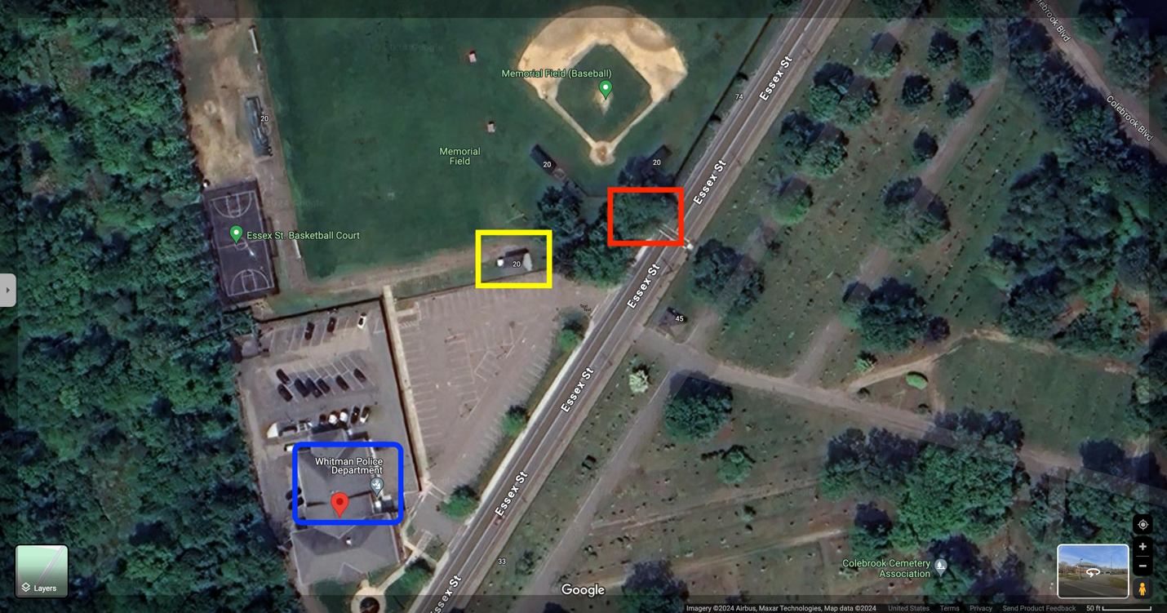

Red Box – EMS access gate

Yellow Box – Equipment shed

Blue box – Whitman Police Department

Whitman Youth Cheer Practice

- Location: 100 Corthell Ave, Whitman Ma 02382
- Shelter: Whitman Middle School
- Medical supplies: First Aid Kit (Band-Aids/Icepacks)
- Practice contact: Team Advisors, Cheer Director, President of program

Medical emergency

- Follow emergency action plan above

Weather related emergency

- If parents are present at practice, athletes will report to their parents vehicles.
- If parents are not present, athletes will stay with coaches until their parents arrive or other action is needed.
- Coaches will remain at practice facility until all athletes have been picked up.
- If weather is extreme, athletes will be directed by coaches to remain inside the Whitman Middle School unless directed otherwise by emergency services.

Cheer Practice Facility
Whitman Middle School
100 Corthell Ave, Whitman Ma 02382

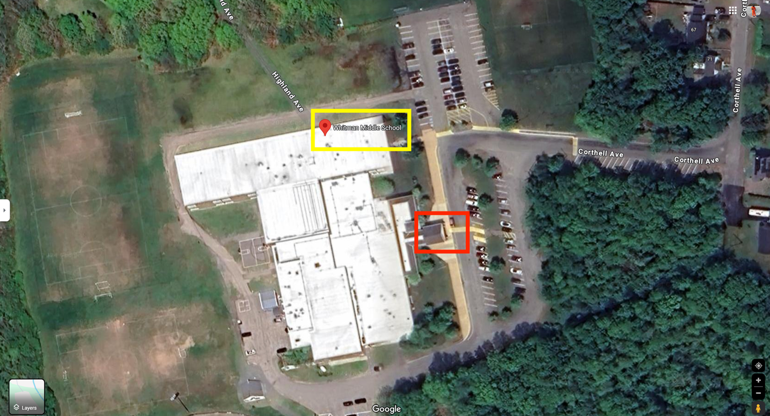

Red Box – Front entrance

Yellow Box – Whitman Middle School

Whitman Youth Football & Cheer Home Games

- Location: 600 Franklin St, Hanson Ma 02341
- Shelter: Whitman Hanson Regional High School
- Medical supplies: AED, First Aid Kit (Band-Aids/Icepacks)
- Game day contact: Team Coaches or President of program

Medical emergency

- Follow emergency action plan above

Weather related emergency

- If parents are present at the game, athletes will report to their parents vehicles.
- If parents are not present, athletes will stay with coaches until their parents arrive or other action is needed.
- Coaches will remain at the game field until all athletes have been picked up.
- If weather is extreme, athletes will be directed by coaches to seek shelter in the High School facilities unless directed otherwise by emergency services.

Whitman Youth Football & Cheer Home Game Field
Whitman Hanson Regional High School
600 Franklin St, Hanson Ma 02341

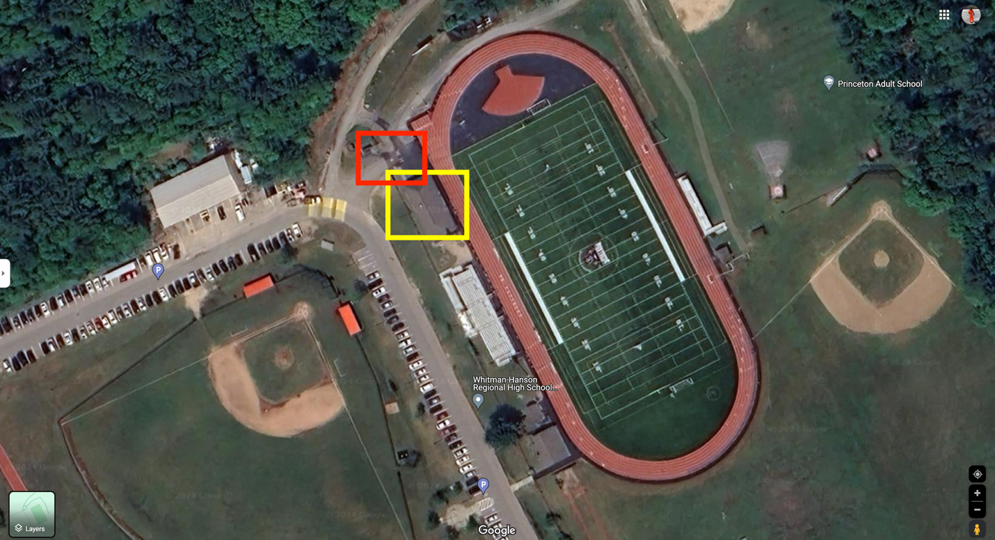

Red Box – Main Gate

Yellow Box – Shelter/Locker room

