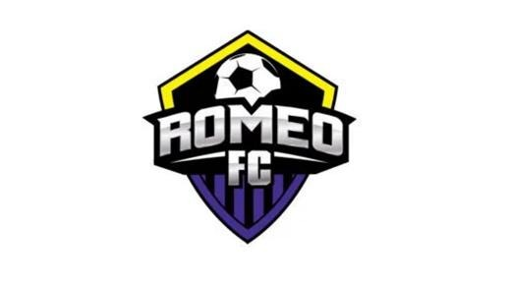Anti-Harassment / Anti-Bullying Policy

Romeo FC is focused on providing a safe environment for children to learn and play soccer. Part of creating a positive environment is to identify and respond to bullying quickly and effectively early on. Unfortunately, bullying can be found in all youth sports, between kids, coaches, and even parents. We rely on every member of the Romeo FC family to identify and report bullying when they see it and, in turn, our Club will support parents, players, referees and coaches when an incident occurs.

Bullying is defined as conduct, gestures or comments which are insulting, intimidating, humiliating, hurtful, malicious, degrading or otherwise offensive to a player, group of players and/or teammates, and which create a hostile or intimidating environment, or which negatively affects a player's physical and/or emotional well-being. Bullying is any written, verbal or physical act, or any electronic communication, whether it is a single incident or a series of incidents that results in intentional pain and distress to the victim.

Some joking and horseplay between people is normal and would not be considered bullying. However, the intent does not always match the result, and even if someone does not mean to cause harm, the person to which the action is taken against, may perceive the action as harmful.

Romeo FC does not tolerate bullying at any practice, game, or Club sanctioned events. We encourage our coaches and parents to know and identify the signs of bullying when they arise. While some children are prone to report bullying to t their parents, coaches, or adults, others will not, due to fear or intimidation.

If you are concerned about bullying on your child’s soccer team, follow these steps to address and amend the issue.

- Talk to your child. Gather as much information about the events as possible and discuss next steps.
- Report incidents to the team coach or manager. If the problem persists, reach out to Romeo FC by completing our online Incident Report. This will alert the necessary people and allow us to take action and respond to the incident.
- For all reported incidents, Romeo FC will speak with the parents of the player who was bullied and may choose to speak with the player and coach as well to understand the extent of the bullying. These discussions are strictly confidential.
- The club will also speak with the parents of the player(s) who were accused of bullying and possibly the players as well to determine the approach for changing the behavior.

Romeo FC has a thorough Anti-Bullying Policy. The following escalation will be applied based on each incident.

- In a first incident of bullying, an attempt will be made to encourage the bully (or bullies) to modify their behavior for their benefit, for the benefit of the person bullied, and for the team. An attempt will be made by the coach, manager, or parent(s) to reconcile the situation between players (age and level of maturity and or severity of offense must be considered)
- If the bullying persists, disciplinary action against a player may be taken by the team, coach and /or Romeo FC Executive Boardwhich may include, but is not limited to, immediate suspension from participation in practices or game(s) for a period of time.
- After the incident/incidents have been investigated and addressed, the situation will continue to be monitored by the respective coach, team manager, and players’ parents to ensure the problem is resolved.

We need toe cooperation of all members of the club (parents, coaches, players and referees) in order to create an environment free of bullying and committed to making everyone’s experience with the Romeo FC a positive one.

_______________________________ | ____________________
Parent/Guardian Signature | Date

