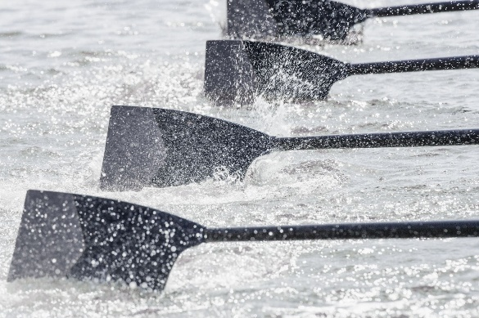
Welcome!
Congratulations, you are officially on a Summer Rowing team!

Next steps:

Registration:
Please go back to our registration site and choose Summer Rowing League. Choose the team number that I sent you (1n, 2n, 3n, 4n)
You can choose either a one-time payment of $535.20 or three installments of $183.06 spread over three months.

Attend ONE of the on-land training sessions. They are scheduled from May 4-7 at 6:00pm at the Boathouse. We will meet in the lobby. No RSVP is needed unless you cannot make any of the nights.
____________________________________________________________________________________
Safe Sport:
All rowers must become members of US rowing.
https://usrowing.org/
Click join at the top left, then go to individual and register. Type in Western Reserve then enter the WRRA Club code is 6NLBT
Choose basic membership, and then the Site will walk you through the process of taking Safe Sport. One of the questions that you will be asked is if you have members under the age of 18, you will need to answer YES. New members are required to take the 90-minute session.
___________________________________________________________________________________

Team Captain:
Each team will need to nominate a team captain. This is the person that the program director and Coach will communicate with.
Team Treasurer:
This person will be responsible for collecting and paying for the Coxswains. WRRA pays for the first 3 sessions, then the team is responsible for the last 10 sessions ($30 per session per team) as well as for the regattas ($10 per race per team). Many of the coxswains will either accept cash (it’s king) or Venmo like app. We pay the cox when they cox for your boat since sometimes you might have a sub.
___________________________________________________________________________________
Download Crossbar app on your phone. This is where the team can chat with each other, coaches, Coxs and attendance is taken.
Google play: https://play.google.com/store/apps/details?id=com.crossbarhq.crossbar&hl=en_US&pli=1
Apple:
https://apps.apple.com/us/app/crossbar-mobile/id1503178320
____________________________________________________________________________________
On water season:
Week of May 11th – Week of August 3rd
Regattas:
These start around 7:30am and last until roughly 1:00pm
Midseason: June 28th
Championship: August 8th.
Sponsorships:
Each team is asked to obtain sponsorship from a business. Many of our teams go to dinner/drinks after rowing and that is typically who sponsors that team. Here is a list of the sponsorships from 2025: https://www.westernreserverowing.com/about/summer-rowing-league-sponsorships/45281
Here is the form for sponsors to fill out: https://docs.google.com/forms/d/e/1FAIpQLSfqBAUKnBnfjqbWorwE9SboJTDxsS1Ns7ngvMOhe3DeTb_UZA/viewform
Sponsorships are $400
WRRA is a certified 501(c)3 organization and relies on donations and other generous contributions from individuals and businesses. We strive to run a lean operation, but membership dues and fees alone are not sufficient to cover the cost of all programs. To achieve our mission while keeping costs at a sustainable level, your $350 sponsorship donation helps fund the many expenses attributed to the sport of rowing in Cleveland and includes:
• Company name and logo imprinted on your sponsored crew’s t-shirts.
• Banner with company name and logo prominently displayed during SRL race day and at the Cleveland Rowing Foundation boathouse.
• Sponsor will receive two team t-shirts (please note sizes below).
• Sponsorship donations are used to help defray costs of running the SRL program including equipment maintenance, coaching fees, t-shirt expense, race day expenses, and boathouse operations.
• All sponsors will receive a 501(c)3 charitable donation receipt for their sponsorship.
____________________________________________________________________________________
Tee shirts:
All teams get tee shirts with their sponsorships.
To ensure I can accommodate your request, please send me the shirt item number, along with your first and second color choices as soon as possible. I’ll do my best to avoid color duplication whenever possible.
Please confirm that the color, size, and style you want are in stock when making your selection.

Tee-shirt options:
https://www.4brandedproducts.com/product/3480/bella--canvas-unisex-jersey-tank.html?color=00
https://www.4brandedproducts.com/product/3001c/bella--canvas-unisex-jersey-t-shirt.html?color=51
https://www.4brandedproducts.com/product/3001cvc/bella--canvas-unisex-heather-cvc-t-shirt.html?color=d9
https://www.4brandedproducts.com/product/6405cvc/bella--canvas-ladies-relaxed-heather-cvc-jersey-v-neck-t-shirt.html
https://www.4brandedproducts.com/product/6405/bella--canvas-ladies-relaxed-jersey-v-neck-t-shirt.html?color=00

Please get this back to me ASAP (deadline: May 16th). I will post on google drive so others can see what is taken already.
You will need to send me (programdirector@westernreserverowing.com) your color choice (1st and 2nd), and team sizes.
____________________________________________________________________________________

I know this is a lot of information. We will cover questions when you attend the on-land training next week.
Looking forward to meeting you all very soon.

Questions…
Heidi Lamb
Programdirector@westernreserverowing.com
440-454-4173

